5. Class Diagram
Entity class diagram
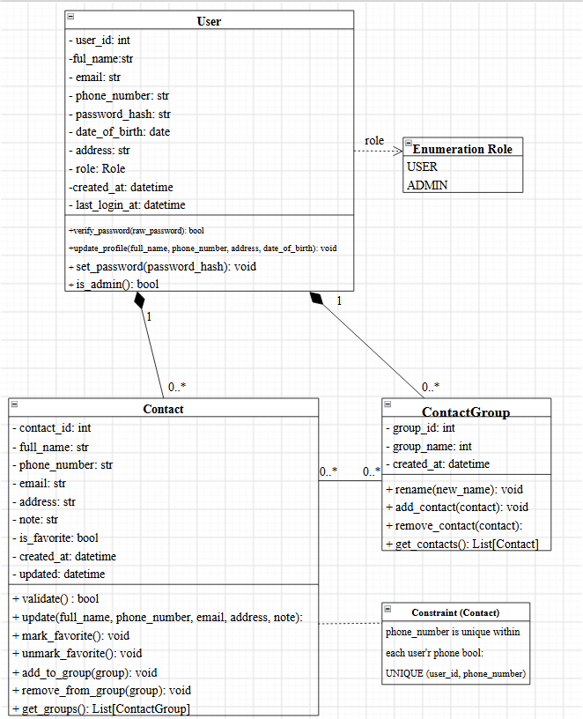
Processing layer class diagram
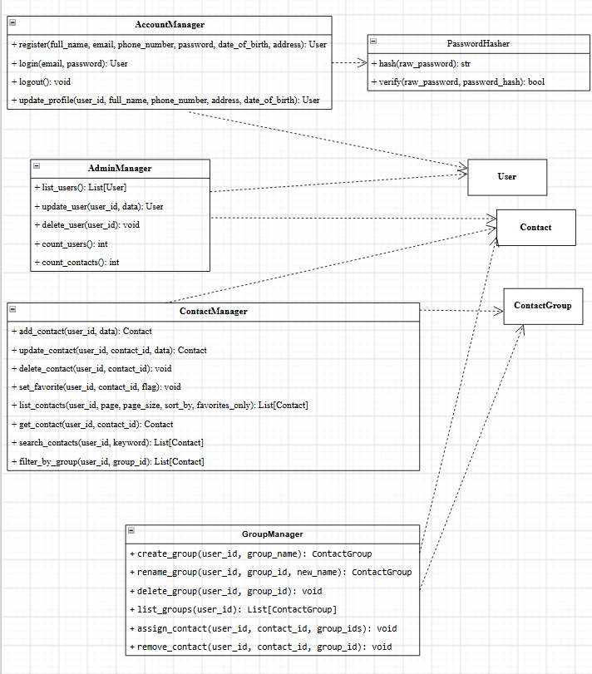
6. Data Model
Mapping between the DFD, classes and database tables
DFD data store | Class | MySQL table | Note
D1 Users | User | users | Accounts and role
D2 Contact | Contact | contacts | Each user's contacts
D3 Groups | ContactGroup | contact_groups, contact_group_members | Groups and the  links between contacts and groups
The many-to-many relationship between Contact and ContactGroup is implemented by the junction table contact_group_members, which belongs to the data store D3 Groups.
Entity relationship diagram (ERD)
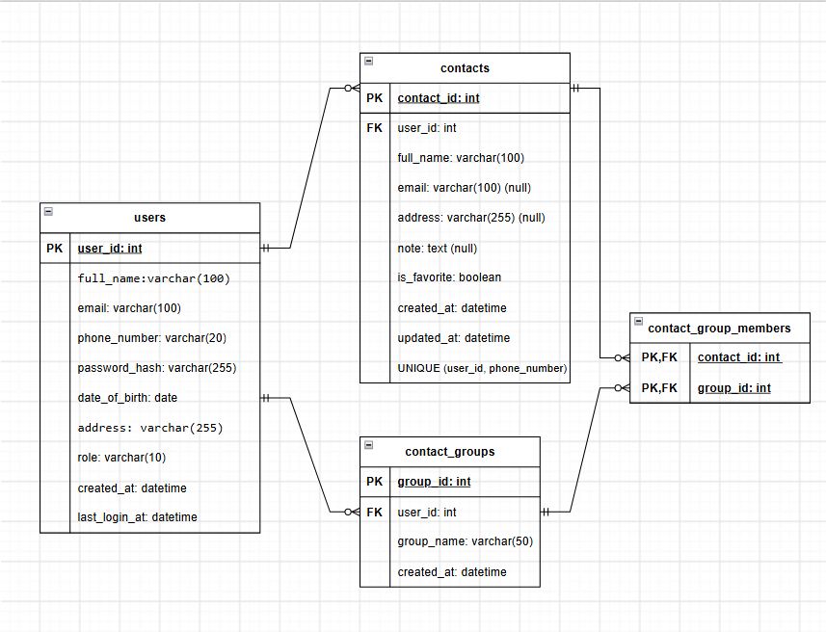
Table specifications
The database management system is MySQL. Tables use the InnoDB engine to support transactions and foreign keys, and the utf8mb4 character set to store Vietnamese text.
Table users
DFD data store: D1 Users. Stores user and administrator accounts.

Column | Data type | Key | Constraints | Description
user_id | INT | PK | PRIMARY KEY; AUTO_INCREMENT | Primary key, auto-increment
full_name | VARCHAR(100) |  | NOT NULL | Full name
email | VARCHAR(100) |  | NOT NULL; UNIQUE | Email, used as the login name
phone_number | VARCHAR(20) |  | NOT NULL | Phone number
password_hash | VARCHAR(255) |  | NOT NULL | Hashed password
date_of_birth | DATE |  | NOT NULL | Date of birth
address | VARCHAR(255) |  | NOT NULL | Address
role | VARCHAR(10) |  | NOT NULL; DEFAULT 'USER'; CHECK (role IN ('USER','ADMIN')) | Role
created_at | DATETIME |  | NOT NULL; DEFAULT CURRENT_TIMESTAM P | Time the account was created
last_login_at | DATETIME |  | NULL | Most recent login time

Table contacts
DFD data store: D2 Contacts. Stores each contact in a user's personal phone book.

Column | Data type | Key | Constraints | Description
contact_id | INT | PK | PRIMARY KEY; AUTO_INCREMENT | Primary key, auto-increment
user_id | INT | FK | NOT NULL; FK →  users(user_id) ON DELETE CASCADE | Owner of the contact
full_name | VARCHAR(100) |  | NOT NULL | Contact full name
phone_number | VARCHAR(20) |  | NOT NULL; UNIQUE together with user_id | Phone number
email | VARCHAR(100) |  | NULL | Contact email address
address | VARCHAR(255) |  | NULL | Address
note | TEXT |  | NULL | Note (optional)
is_favorite | BOOLEAN |  | NOT NULL; DEFAULT FALSE | Favorite flag
created_at | DATETIME |  | NOT NULL; DEFAULT CURRENT_TIMESTAMP | Creation time
updated_at | DATETIME |  | NOT NULL; DEFAULT CURRENT_TIMESTAMP | Time of the most recent  update
Additional unique constraint: (user_id, phone_number).
Table contact_groups
DFD data store: D3 Groups. Stores the groups (categories) created by users, e.g. Family, Friends, Work.

Column | Data type | Key | Constraints | Description
group_id | INT | PK | PRIMARY KEY; AUTO_INCREMENT | Primary key, auto-increment
user_id | INT | FK | NOT NULL; FK →  users(user_id) ON DELETE CASCADE | User who created the group
group_name | VARCHAR(50) |  | NOT NULL | Group name
created_at | DATETIME |  | NOT NULL; DEFAULT CURRENT_TIMESTAMP | Creation time
Additional unique constraint: (user_id, group_name).
Table contact_group_members
DFD data store: D3 Groups. Junction table of the many-to-many relationship between contacts and groups.
Column | Data type | Key | Constraints | Description
contact_id | INT | PK, FK | PRIMARY KEY; FK →  contacts(contact_id) ON DELETE  CASCADE | Part 1 of the primary key, references the  contact
group_id | INT | PK, FK | PRIMARY KEY; FK →  contact_groups(group_id) ON DELETE CASCADE | Part 2 of the primary key, references the group
Indexes
Primary keys and UNIQUE constraints are indexed automatically. The additional indexes support the performance requirements (search results within 0.5 seconds for 10,000 records, up to 50,000 contacts per account):

Index name | Table | Columns | Purpose
idx_contacts_user_name | contacts | (user_id, full_name) | Listing, sorting A-Z / Z-A and searching by name within one user's contacts
uq_contacts_user_phone | contacts | (user_id, phone_number) | Unique per user; also used for searching by phone number
idx_contacts_user_created | contacts | (user_id, created_at) | Sorting by creation date
idx_contacts_user_fav | contacts | (user_id, is_favorite) | Viewing the favorites list
idx_members_group | contact_group_members | (group_id) | Filtering contacts by  group

